Source Analysis – Adolf Hitler

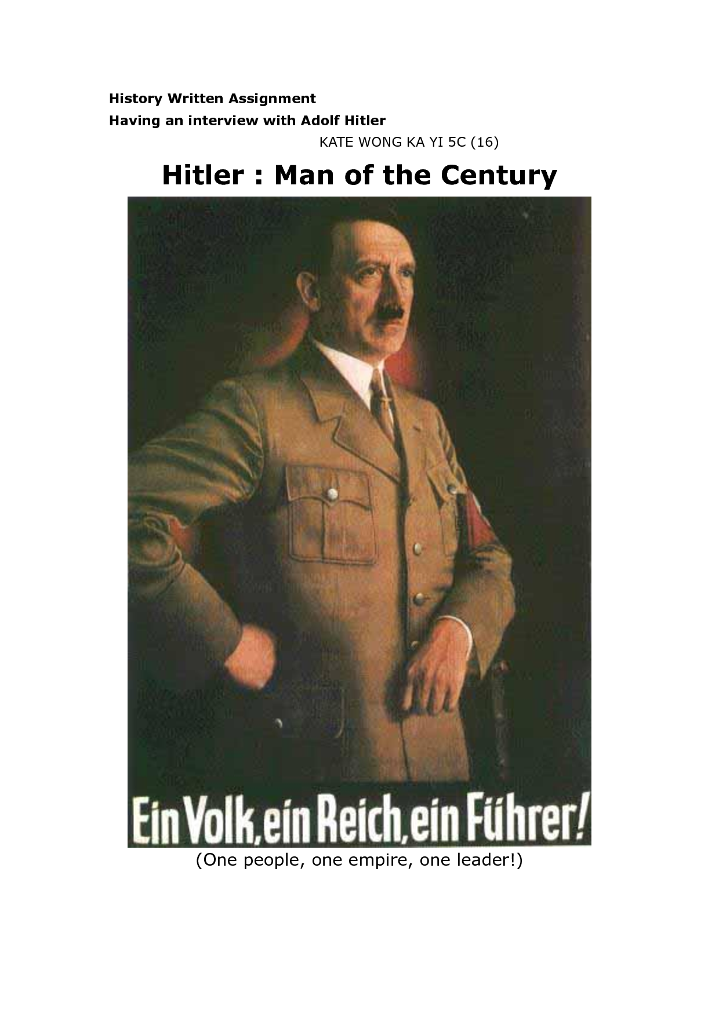

***SOURCE 2:***

***A 1938 Nazi poster depicting Adolf Hitler with the tagline: ‘One people, one empire, one leader!***

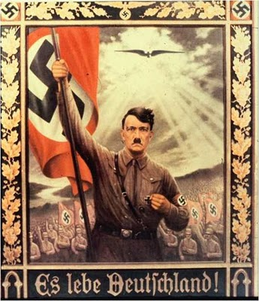

***SOURCE 1:***

***A 1936 Nazi poster depicting Adolf Hitler with the tagline: ‘Long live Germany!’***

**Answer the following questions for each source:**

|  |  |
| --- | --- |
|  | ***Source 1*** |
| When and where was the source made? | 1936 Germany |
| What are the main objects and/or people that you can see? How are they portrayed? | Hitler carrying Nazi flag  Flanked by Nazi army / supporters  Portrayed as strong; leader; forceful; forward-moving |
| What words or phrases are present? What do you think they mean? | Long live Germany |
| What symbols or images are used? What meaning are these symbols or images intended to convey? | The eagle symbolizes the strength of the Nazi party, the swastika represents the Nazi party generally. And the sun shing over the Nazis represents a divine aid of the party. |
| What message do you think this poster is intending to convey? | Nazi party is responsible for the resurrection of Germany and will continue this in the future. |

|  |  |
| --- | --- |
|  | ***Source 2*** |
| When and where was the source made? | 1938 Germany |
| What are the main objects and/or people that you can see? How are they portrayed? | Hitler who I portrayed as a well-dressed powerful man |
| What words or phrases are present? What do you think they mean? | One people, One Empire, One leader!  This means that Germany should be united under Hitler |
| What symbols or images are used? What meaning are these symbols or images intended to convey? | Red, white and black are used as they were the party’s colours  He has an important looking stance  He is wearing a swastika arm band to show loyalty to the party |
| What message do you think this poster is intending to convey? | Hitler will unite Germany as an empire |